

Department of Software Engineering
Final Project - Phase B (61998)
Robot Eco Farm
A robot for monitoring cherry tomatoes in a greenhouse using segmentation,
computer-vision rules, and a cluster heuristic
26-1-R-6
Project Details
Submitted by | Israel Ohayun - Israel.Ohayun@e.braude.ac.il
Supervisor | Dr. Naomi Unkelos-Shpigel
Supervisor | Mr. Uzi Rosen
Project code | https://github.com/xsrel77/Ronen-Autonomous-Vehicle-
Date | July 2026

Abstract
This project presents a robotic system for monitoring the ripeness of cherry tomatoes and tomato clusters in a greenhouse in Karmiel. Greenhouse scenes are characterized by occlusion, overlapping fruit, dense foliage, changing illumination, and frame-to-frame variation. Under these conditions, relying only on a model confidence score creates a trade-off between filtering false detections and missing genuine fruit and clusters.
The research examined the extent to which a lightweight YOLOv8s-seg model, combined with computer-vision rules based on colour, masks, density, region-of-interest validity, temporal consistency, and cluster structure, improves detection and classification on a resource-constrained robot. The solution runs a TensorRT FP16 engine on a Jetson Orin Nano and applies an explainable policy vector to the segmentation output. The policy separates strong detections, Review detections, colour corrections, weak detections, and noise. An additional heuristic uses a weak cluster prediction as a spatial anchor and individual tomato detections as supporting evidence to create a ripe, unripe, or Mixed cluster.
The evaluation used 66 annotated test images containing 820 objects, three greenhouse videos totalling approximately 90.1 seconds, and 15 Sessions recorded by the robot. On the annotated sample, Recall increased from 86.22% to 88.05% a statistically significant gain of 1.82 percentage points-whereas Precision decreased from 93.03% to 91.74%. The changes in F1 and Object Accuracy were not significant. Ablation analysis showed that the Review layer made the more stable contribution: 11 of its 16 added detections were correct. By contrast, colour correction added four true detections and seven false detections and increased temporal instability in the videos.
The heuristic was activated six times in the greenhouse videos and produced 177 cluster predictions during the seven post-update Sessions. These findings demonstrate operational feasibility and controlled use of consistent noise, but they do not establish a significant improvement in cluster accuracy because the videos and Sessions lack Ground Truth. The main conclusion is that the hybrid solution primarily improved system sensitivity and reduced missed detections. Further calibration of the colour-correction rule and direct FPS measurement on the robot are still required for a complete quantitative claim of real-time operation.
Key finding
The significant improvement was in Recall, not in the overall metric: the new system detects more genuine objects at the cost of a moderate decrease in Precision.

Keywords: YOLOv8s-seg, segmentation, cherry tomatoes, greenhouse, Edge AI, Jetson Orin Nano, computer vision, heuristic, temporal consistency.

Table of Contents
Abstract | -
Chapter 1 - Introduction | 1
1.1 Problem and Need | 1
1.2 Research Question | 1
1.3 Project Objectives | 2
1.4 Contribution, Scope, and Limitations | 2
Chapter 2 - Background and Brief Literature Review | 3
2.1 Ripeness Detection and Segmentation in Greenhouses | 3
2.2 Lightweight Models and Edge Deployment | 3
2.3 Research Gap | 3
Chapter 3 - Final Solution and Architecture | 4
3.1 Operating Scenario and Requirements | 4
3.2 Hardware Architecture | 4
3.3 Software Architecture | 5
3.4 Processing Flow | 6
3.5 Mapping, Recording, and Client Application | 7
Chapter 4 - Research Method and Hybrid Algorithm | 8
4.1 Dataset and Augmentation | 8
4.2 Model Training and Results | 9
4.3 Candidate and Feature Extraction | 10
4.4 Policy Vector | 11
4.5 Review and Colour Correction | 12
4.6 Cluster Heuristic | 13
4.7 Temporal Consistency | 14
Chapter 5 - Experiments, Results, Discussion, and Conclusions | 15
5.1 Evaluation Methodology | 15
5.2 Test-Set Composition | 15
5.3 Quantitative Results | 16
5.4 Ablation Analysis: Review versus Colour Correction | 17
5.5 Temporal Consistency in Greenhouse Videos | 18
5.6 Cluster Heuristic and Session Results | 19
5.7 Discussion, Answer to the Research Question, and Conclusions | 20
References | 20

Table of Contents - Appendices
Appendices | 21
Appendix A - Hardware Architecture | 21
Appendix B - Software Architecture | 22
Appendix C - Full Processing Flowchart | 23
Appendix D - Dataset and Training Details | 24
Appendix E - Policy Thresholds and Pseudocode | 25
Appendix F - Detailed Results | 26
Appendix G - Examples from the Annotated Test Set | 27
Appendix H - Heuristic Examples from Greenhouse Videos | 28
Appendix I - Additional Video Examples | 29
Appendix J - Client-Side Dashboard for Session Analysis | 30
Page numbering begins with Chapter 1.
The abstract and the two table-of-contents pages are excluded from the 20-page main-text limit; the appendices begin after page 20.

Chapter 1 - Introduction

1.1 Problem and Need
Monitoring cherry tomatoes in a greenhouse requires repeated passes along the crop rows, assessment of fruit colour, and documentation of cluster condition. Manual inspection is labour-intensive, depends on the observer's judgement, and does not guarantee consistent records of the same areas over time. This project turns the survey into a documented robotic process: the robot moves between the plants, captures the scene, produces predictions, and stores the results with timestamps and location data.
The primary challenge is not merely locating a tomato, but producing a stable and useful result in a dense greenhouse scene. Leaves and stems obscure parts of the fruit; tomatoes overlap within clusters; direct light, shadows, and reflections alter the measured colour; and intermediate hues complicate the distinction between ripe and unripe. Robot and camera motion also change distance and viewpoint, so the same object may receive different labels in adjacent frames.
A solution based solely on raising the confidence threshold reduces false detections but may reject genuine, partially visible objects. Increasing model size is also insufficient because the system must run on a resource-constrained robot while simultaneously supporting mapping, control, display, and recording. This motivated a lightweight, explainable external decision layer that exploits the segmentation mask and scene context.

1.2 Research Question
Research question
To what extent does combining a lightweight YOLOv8s-seg model with computer-vision rules based on colour, masks, density, temporal consistency, and cluster structure improve the detection and classification of tomatoes and tomato clusters in dense greenhouse scenes, while maintaining real-time operation on a resource-constrained robotic system?

The question is evaluated by comparing a strict policy that accepts only detections meeting conservative thresholds with a combined policy that can recover weak detections supported by visual and structural evidence. The comparison separates changes in coverage, precision, and stability so that added detections are not assigned research significance without Ground Truth support.

1.3 Project Objectives
Research objective - Determine whether an explainable rule layer above a lightweight model improves the detector's operating point without training a larger model.
Detection objective - Detect individual tomatoes and clusters and classify maturity as Ripe, Unripe, or only for heuristic clusters Mixed.
Policy objective - Combine confidence, mask area and density, colour, ROI validity, and spatial support to distinguish Strong, Review, Weak, and Noise candidates.
Stability objective - Reduce transient detections and label switching through class competition and temporal tracking.
Engineering objective - Integrate the algorithm on the robot, record reproducible Sessions, and present predictions, the map, and the route in a client application.

1.4 Contribution, Scope, and Limitations
The main contribution is a policy vector that separates the model score from the system decision. Instead of artificially increasing YOLO confidence, every result retains an explicit source and status. Review denotes a weak candidate supported by mask and colour evidence; Color Corrected denotes a relabeled detection; and Heuristic denotes a cluster generated from a weak anchor and supporting tomatoes. This separation supports explanation, replay, and ablation analysis.
A second research observation was the presence of consistent noise. The strict policy rejected many cluster predictions, yet some weak cluster candidates repeatedly appeared in the same regions around several individual tomatoes. The new heuristic treats the weak candidate as a spatial frame, evaluates the tomatoes inside it, and emits a ripe, unripe, or Mixed cluster only when sufficient support exists.
The work focuses on visual monitoring rather than harvesting or disease diagnosis. The map produced with ROS 2 Humble and SLAM Toolbox was used for documentation and progress display; full autonomous navigation was not completed. Experiments used one greenhouse and one camera, the videos and Sessions lack complete Ground Truth, and offline runtime measurements do not replace end-to-end measurements on the robot.
Reporting principle
Session counts are reported as operational evidence. Claims about Precision, Recall, F1, and Accuracy are based only on the annotated test set.

Chapter 2 - Background and Brief Literature Review

2.1 Ripeness Detection and Segmentation in Greenhouses
Colour is a central indicator of tomato ripeness, but in a greenhouse it is affected by shading, reflections, and camera characteristics. Moreira et al. (2022) compared deep-learning models with an HSV colour-space approach for detecting and classifying greenhouse tomatoes. Their study demonstrates the value of explicit colour features and their limitations under changing light and occlusion. In the present project, colour does not replace the model; it provides additional evidence derived only from segmentation-mask pixels.
Wei et al. (2025) addressed ripeness detection and fruit segmentation using instance segmentation. An instance-level mask separates the fruit from the background and enables features that cannot be derived from a bounding box alone. This capability underpins the present solution: YOLOv8s-seg provides a box and mask for each candidate, and the policy derives colour ratios, area, and density from the mask.

2.2 Lightweight Models and Edge Deployment
A robotic system must balance prediction quality, processing time, and memory use. Weng et al. (2025) presented a network for identifying tomato components in unstructured environments and demonstrated deployment on a Jetson Orin Nano. Their work supports the feasibility of real-time agricultural processing on an edge computer, while also emphasizing that model selection is only one part of the system: preprocessing, decoding, tracking, and recording introduce additional overhead that must be measured separately.

2.3 Research Gap
The reviewed studies establish three foundations: deep learning for detection, colour for ripeness assessment, and models suitable for edge deployment. The gap addressed here is their systematic integration in an explainable decision layer above an existing model, including deliberate use of weak predictions and their spatial and temporal consistency. The goal is not to claim that rules always improve a model, but to measure which rules improve Recall, which add False Positives, and which demonstrate only operational feasibility.
Research context
The solution is evaluated through component ablation: Strict → Review → Review+Colour → Full Policy. This separates the contribution of each layer from the overall change.

Chapter 3 - Final Solution and Architecture

3.1 Operating Scenario and Requirements
The operator drives the robot through the greenhouse aisles and aims the pan-tilt camera at the plants. The detection pipeline runs on every frame; results are displayed in the local interface and stored while a Session is recorded. The system was required to run continuously on the robot, retain weak candidates for research, record each decision source, and synchronize predictions with time and location.

3.2 Hardware Architecture
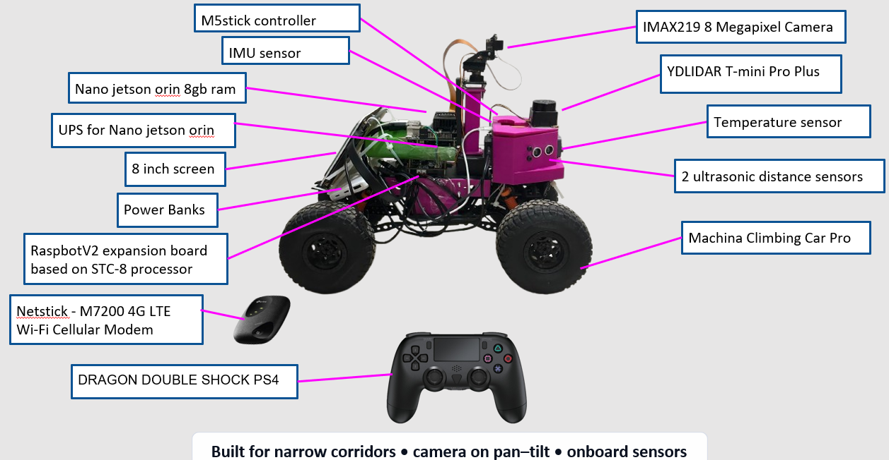
Figure 3.1 - Robot hardware components and their placement in the system.
A Jetson Orin Nano with 8 GB RAM serves as the main processing unit. An 8 MP IMX219 camera is mounted on a pan–tilt mechanism; a YDLIDAR T-mini Pro Plus supplies scans for SLAM; an STC8-based RaspbotV2 board drives the motors; and IMU, temperature, and ultrasonic sensors complement environmental sensing. The local display, power units, and cellular modem support stand-alone field operation.

3.3 Software Architecture
A central C++ application on the Jetson Orin Nano manages the camera, TensorRT FP16 engine, YOLOv8s-seg mask decoding, policy vector, heuristic, tracking, and recording. In parallel, ROS 2 Humble and SLAM Toolbox perform mapping, while the control layer forwards joystick commands to the motors and camera-angle actuators through the STC8 board.
The system is divided into three paths-vision, mapping, and control-which converge in the local interface and Session record. This separation allows predictions to be recorded even when no map is available and enables post-experiment analysis of the relationship between image, policy, and location.
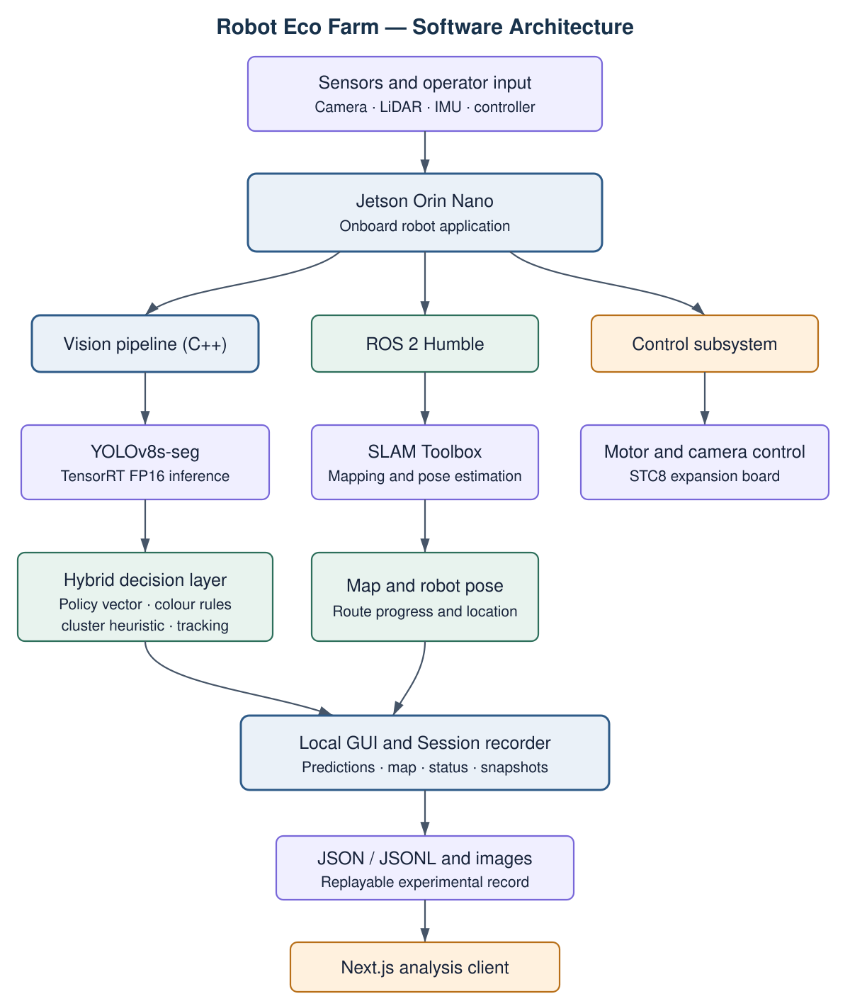
Figure 3.2 - Software architecture and information flow among vision, mapping, control, and recording.

3.4 Processing Flow from Image Capture to Result
The camera produces a 1280×720 frame. After optional digital zoom, letterboxing resizes the input to 640×640, and the frame is processed by the YOLOv8s-seg TensorRT FP16 engine. A low raw threshold of 0.15 retains weak candidates, NMS at 0.45 removes duplicates, and a segmentation mask is reconstructed for each remaining candidate.
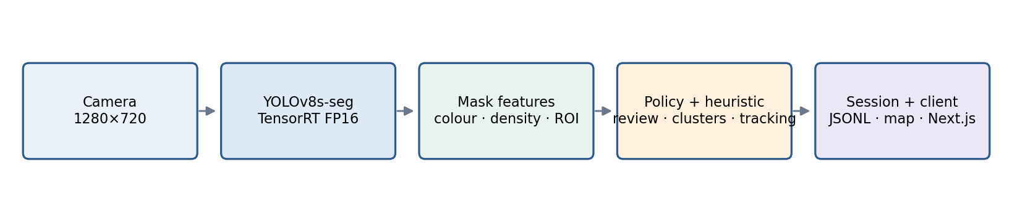
Figure 3.3 - Condensed processing pipeline in the operational system.
Stage | Operation | Output
1 | Camera capture and preprocessing | 640×640 frame
2 | TensorRT inference and YOLO decoding | Class, confidence, BBOX, and mask
3 | Feature computation | Colour, area, density, and ROI
4 | Policy | Strong, Review, Weak, or Noise
5 | Heuristic and tracking | Clusters and temporally stable decision
6 | Recording | Images, JSON/JSONL, map, and Session

When no strong cluster is accepted, the system can perform an additional ROI pass once every three frames and analyse up to two focused crops. The merged predictions then undergo colour correction, Review, heuristic inference, maturity-class competition, and tracking. The final result is stored alongside the raw candidates, making each decision reproducible.

3.5 Mapping, Recording, and Data Presentation
ROS 2 Humble receives LiDAR scans and runs SLAM Toolbox to build a map and display robot progress. The map supported documentation and provided a foundation for future navigation; robot motion during the experiments was manually controlled. When a map pose is available, predictions are linked to it so crop areas can be revisited.
A Session represents one operating interval. It stores source and annotated images, raw candidates, post-policy results, timestamps, robot status, and map location. Events containing an accepted detection are stored at most once per second; events containing only weak candidates are stored at a lower rate to document consistent noise without overwhelming storage.
Data item | Research use
raw_candidates.jsonl | Replay YOLO output before the policy decision
detection_events.jsonl | Strong, Review, Colour, and Heuristic results
Source and annotated images | Visual verification of successes and failures
map_pose_timeline | Time and location linkage along the route
Video | Persistence, class-switch, and transient-noise analysis

The data feed the Policy Replay Lab, which reruns the policy on the same candidates, and the Next.js client, which presents images, the route, camera angles, and predictions on the map. This creates an end-to-end sequence: onboard real-time processing, reproducible recording, and post-experiment visual analysis.
Architectural advantage
Storing raw candidates separately from final results allows the policy to be changed without retraining YOLO or repeating a greenhouse run for every revision.

Chapter 4 - Research Method and Hybrid Algorithm

4.1 Dataset and Augmentation
The dataset was created as a fork of TOMATO on Roboflow Universe. The original dataset contained 466 images with individual-tomato segmentation; 20 images from the Karmiel greenhouse were added. Individual-tomato annotations were corrected with SAM, and masks were added for ripe and unripe clusters. The four model classes are ripe bunch, ripe tomato, unripe tomato, and unripe bunch.
Split | Images | Share | Augmentation
Train | 486 | 71% | Yes
Validation | 133 | 19% | No
Test | 66 | 10% | No

After annotation, 60 tomato-free greenhouse images with empty label files were added to expose the model to leaves and green backgrounds. In practice, 62 negative sources were processed because the notebook also included two preview images. This detail is reported for exact reproducibility.
Augmentation was applied only to the training set. Fourteen photometric and geometric variants were generated for each positive image, and every variant was combined with five angles. Transformations included brightness, gamma, shadow, Gaussian blur, motion blur, noise, zoom-in, and zoom-out over a greenhouse background. Geometric operations also updated the segmentation polygons. Only five rotation variants were generated for negative images.
Split | Final images | Unlabeled | Annotated instances
Train | 34,330 | 310 | 433,787
Validation | 133 | 0 | 1,645
Test | 66 | 0 | 820

The number of training files should not be confused with genuine diversity: 34,020 positive images were derived from only 486 source images. Furthermore, approximately 90.3% of instances were individual tomatoes and only 9.7% were clusters. These limitations directly affected cluster-mask quality.

4.2 Model Training and Results
Training began with pretrained YOLOv8s-seg weights, 640×640 input, and batch size 8 on an RTX 4060 Ti. Thirty epochs were planned with an early-stopping patience of 10. Training stopped after 14 epochs, and best.pt was selected at epoch 4. Training took approximately 2.27 hours. Because most augmentation had been performed offline, mosaic, rotations, and flips were disabled during training.
Class | Box mAP50 | Mask P | Mask R | Mask mAP50
All classes | 0.914 | 0.673 | 0.674 | 0.641
Ripe bunch | 0.905 | 0.490 | 0.474 | 0.366
Ripe tomato | 0.954 | 0.928 | 0.935 | 0.946
Unripe tomato | 0.879 | 0.832 | 0.853 | 0.879
Unripe bunch | 0.918 | 0.442 | 0.435 | 0.374

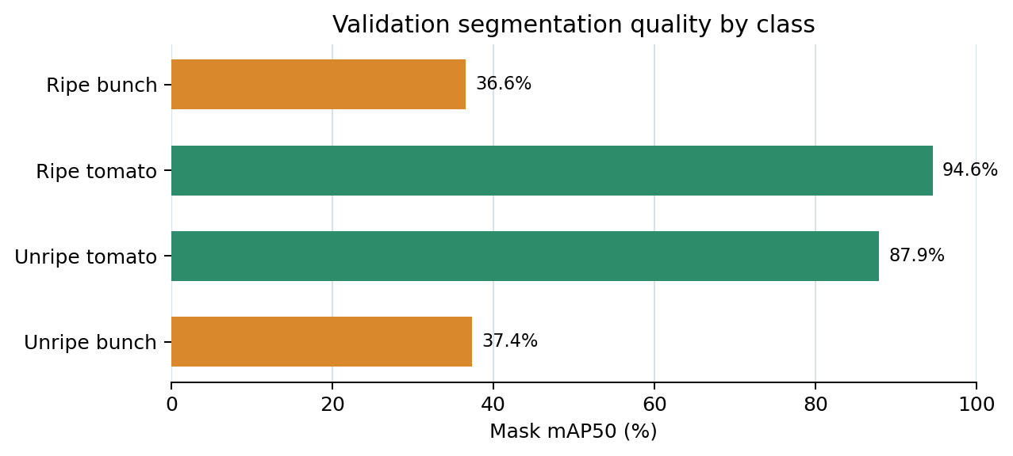
Figure 4.1 - Validation-mask quality gap between individual tomatoes and clusters.
The main training result is a gap between cluster localization and mask quality. Cluster boxes reached mAP50 values of 0.905 and 0.918, but Mask mAP50 was only 0.366 and 0.374; Mask mAP50–95 was approximately 0.09. By contrast, individual-tomato masks reached 0.946 and 0.879. This gap motivates the hybrid architecture: a weak cluster box can serve as an anchor, while individual-tomato masks provide precise colour and structural evidence.

4.3 Candidate and Feature Extraction
For each frame, YOLOv8s-seg produces candidates from a score of 0.15. Every candidate contains a class, confidence, bounding box, mask, and mask coefficients. After NMS, the mask is reconstructed and geometric and colour features are computed. The mask prevents background pixels inside the bounding box from affecting measurement: colour ratios are computed only from valid mask pixels.
Feature | Role in the policy
class, confidence | YOLO class and original confidence score
BBOX area | Filter boxes that are too small or too large
mask area | Number of pixels marked as the object
mask density | Mask area divided by bounding-box area
red / orange / warm | Ripeness evidence derived from the mask
green-yellow | Unripe-colour evidence
ROI validity | Check the candidate-centre location
child support | Number and weight of tomatoes within a cluster anchor

Mask density is defined as the number of mask pixels divided by the bounding-box area. A low value may indicate a partial mask, an overly broad box, or an occluded cluster. Colour ratios are the share of valid mask pixels that fall within the relevant HSV ranges.
Separation of responsibilities
YOLO produces candidates and masks; the policy does not alter the network weights, but decides how to use the available evidence.

A candidate record is retained even when rejected. The raw candidate can therefore be compared with the final result to determine whether the decision followed from confidence, mask quality, colour, ROI, cluster support, or temporal consistency. This capability underpins the Policy Replay experiment and the ablation analysis in Chapter 5.

4.4 Strict Policy Vector
The policy vector aggregates model, mask, and contextual evidence for each candidate. Each class has a different confidence threshold: 0.80 for ripe tomato, 0.85 for unripe tomato, 0.65 for ripe bunch, and 0.70 for unripe bunch. Passing the confidence threshold alone is insufficient; size, density, ROI, colour, and basic object plausibility are also evaluated.
Layer | Question | Effect
Confidence | Did the model pass the class threshold? | Strong or Weak
Geometry | Are the box and mask plausibly sized? | Accept or reject
Mask density | Does the mask fill enough of the box? | Mask reliability
Colour | Is colour consistent with a tomato and its maturity? | Review or correction
ROI | Is the candidate centre inside the target ROI? | Edge filtering
Structure | Is the cluster supported by internal tomatoes? | Promotion or heuristic

Final statuses
Status | Meaning
Strong | Passed class conditions and was accepted as a strong model prediction
Review | Failed the strict threshold but received mask and colour support
Weak | Retained for analysis or support but not displayed as a regular result
Noise | Failed basic validity checks and is not used for a decision
Heuristic | New cluster generated from a weak anchor and supporting tomatoes

The strict policy reduced noise but exposed an important pattern: weak cluster predictions repeatedly appeared around genuine regions. The system therefore does not discard the Weak set. It retains these candidates as an evidence pool from which Review candidates can be promoted, an additional ROI pass can be triggered, or a heuristic cluster can be created.
Transparency principle
The new status does not alter YOLO confidence. The original confidence is retained and the decision source is recorded in a separate field.

4.5 Review Promotion and Colour-Based Relabeling

Review
A weak tomato candidate may be promoted to Review when the mask is valid, its density is sufficient, the region lies within the ROI, and colour evidence is consistent with a tomato. Review is not a Strong prediction and receives no new confidence score; it is displayed and stored with a separate status. Its purpose is to recover candidates rejected by a conservative confidence threshold despite plausible visual evidence.

Colour correction
When a tomato mask is reliable but the maturity class strongly contradicts the colour distribution, the policy may switch Ripe to Unripe or vice versa. Correction is applied only after area and density checks, avoiding reliance on a small or unstable mask. The rule uses red, warm-colour, and green–yellow ratios within the mask.
Case | Condensed condition | Result
Review ripe | Valid mask + warm evidence + near-threshold confidence | Accepted with explicit status
Review unripe | Valid mask + green–yellow evidence + near-threshold confidence | Accepted with explicit status
Unripe → Ripe | Strong red/warm evidence contradicts the class | Color Corrected
Ripe → Unripe | Strong green–yellow evidence contradicts the class | Color Corrected
Weak mask | Low area or density | No correction

The two layers were designed independently and can therefore be evaluated by ablation. This distinction proved essential: Chapter 5 shows that Review mainly added correct, temporally supported detections, whereas colour correction increased both the number of detections and the number of singletons and class switches.
Colour-rule limitation
The warm range also includes orange. Some orange tomatoes in the dataset were labeled unripe, so an overly broad warm rule may incorrectly relabel them as ripe.

4.6 Cluster Heuristic
The heuristic was developed in response to the consistent noise revealed by the conservative policy. A weak cluster prediction is used only as a spatial anchor. It is not automatically accepted, but is evaluated against individual tomatoes whose centres lie within or near it.
Stage | Operation
A - Anchor selection | Weak cluster prediction satisfying minimum geometric conditions
B - Child collection | Locate strong and weak individual tomatoes inside the anchor
C - Weighting | Higher weight for strong detections and valid mask/colour evidence
D - Maturity decision | Compute Ripe and Unripe support; a small margin yields Mixed
E - Final box | Union of anchor and tomato boxes, 4% padding, and duplicate filtering

Acceptance requires a minimum number of tomatoes and a minimum weighted support sum. Each tomato contributes according to both its model-predicted class and mask colour. If the ripe score exceeds the unripe score by the required margin, a Ripe bunch is produced; the reverse yields an Unripe bunch; and meaningful support for both sides without a sufficient margin yields Mixed.
for each weak_bunch_anchor:
children = tomatoes_inside(anchor)
if support(children) < minimum: continue
ripe_score, unripe_score = maturity_evidence(children)
label = decide(ripe_score, unripe_score, margin=0.60)
emit(label, union_box(anchor, children), source='heuristic')

A heuristic prediction has no YOLO confidence: the primary confidence field is set to 0, anchor confidence is retained separately, and the result source is heuristic. At most two heuristic clusters are displayed per frame, and a cluster is rejected when its overlap with another cluster exceeds 0.30.
Research rationale
The weak anchor provides a hypothesis about cluster structure; individual tomatoes provide validation and maturity evidence. In this way, consistent noise becomes explainable structural evidence.

4.7 Class Competition and Temporal Consistency
In a dense scene, the same fruit may receive overlapping Ripe and Unripe predictions in one frame. Within-frame competition is applied first: competing tomatoes require high IoU, while clusters use a lower overlap threshold because their boxes vary more in size. The decision score combines confidence, colour, and density; cluster decisions also include support from internal tomatoes.
After competition, detections are assigned to tracks by IoU with object-type awareness. A new track is displayed only after three appearances. It is retained for up to eight unmatched frames to allow reconnection after brief occlusion, but an old box is not drawn without a current detection.
Tracking parameter | Value
IoU matching threshold | 0.35
Appearances before display | 3
Maximum unmatched age | 8 frames
Margin for immediate class change | 0.12
Persistence for class change | 4 frames

Hysteresis prevents immediate maturity-label switching. A new class is accepted only when its score is substantially stronger than the stable class or when it persists for four consecutive frames. Geometry and mask remain those of the current frame, while the label is held until one of these conditions is met.
Strong, Review, and Color Corrected predictions are tracked. Heuristic clusters are generated after tracking and recomputed in every frame; their supporting tomatoes are temporally stable, but the heuristic cluster itself does not receive a direct track. This is a limitation of version 32 and a target for future work.
Algorithm summary
Mask and colour provide visual evidence, child support provides spatial context, and tracking provides temporal stability. Each layer is recorded separately for comparison.

Chapter 5 - Experiments, Results, Discussion, and Conclusions

5.1 Evaluation Methodology
The evaluation used three complementary levels. An annotated image set supports accuracy metrics; videos support temporal-consistency analysis; and robot Sessions describe operational behaviour under real deployment conditions. All comparisons used the same model predictions and images so that changes could be attributed to the policy alone.
Configuration | Components
P0 - Strict | Thresholds, area, density, and basic support
PR - Review | P0 + Review acceptance; ablation only
P1 - Review and Color | PR + colour-based relabeling
P2 - Full Policy | P1 + cluster heuristic

Experiment | Sample | Measurements
Annotated test set | 66 images, 820 objects | Precision, Recall, F1, Object Accuracy
Video | 3 videos, 271 frames | Temporal support, singletons, and class switches
Sessions | 8 before + 7 after the update | Statuses, activation volume, and heuristic predictions

5.2 Test-Set Composition
Class | Objects | Images
Ripe bunch | 46 | 41
Ripe tomato | 504 | 54
Unripe tomato | 242 | 37
Unripe bunch | 28 | 27

Ground Truth matching was one-to-one at Box IoU = 0.5. A paired bootstrap with 5,000 image-level iterations was performed. The set contains no Mixed class, so a Mixed prediction would count as an abstention. In practice, P2 produced no Mixed predictions and did not activate the heuristic on the static set.

5.3 Quantitative Results on the Test Set
Metric | P0 | P1 | P2
TP | 707 | 722 | 722
FP | 53 | 65 | 65
FN | 113 | 98 | 98
Precision | 93.03% | 91.74% | 91.74%
Recall | 86.22% | 88.05% | 88.05%
F1 | 89.49% | 89.86% | 89.86%
Object Accuracy | 80.99% | 81.58% | 81.58%

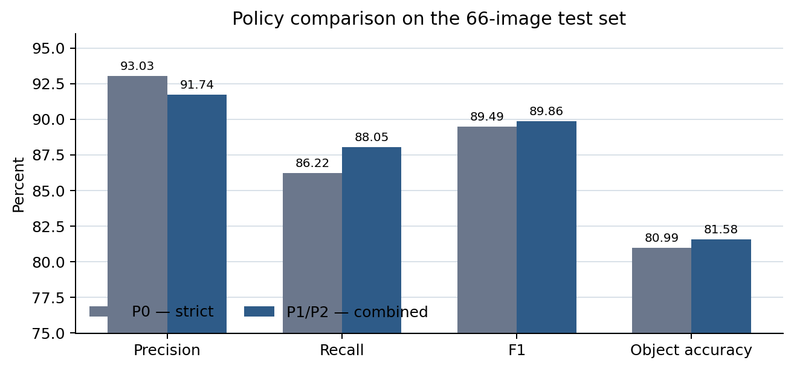
Figure 5.1 - Shift in operating point from P0 to the combined policy on the test set.
The combined policy detected 15 additional true objects and reduced missed detections from 113 to 98. Recall increased by 1.82 percentage points, with a 95% confidence interval of 0.99 to 2.76 points a significant improvement. At the same time, 12 False Positives were added and Precision decreased by 1.29 points, with a 95% confidence interval of −2.13 to −0.58 a significant decline.
Statistical interpretation
F1 increased by 0.36 points and Object Accuracy by 0.60 points, but neither change was significant. The evidence therefore supports improved sensitivity rather than an unambiguous overall improvement.

5.4 Ablation Analysis: Review versus Colour Correction
To identify which component caused the change, the detections added by Review and colour correction were evaluated separately. Of the 27 new P1 detections, Review added 16 and colour correction added 11.
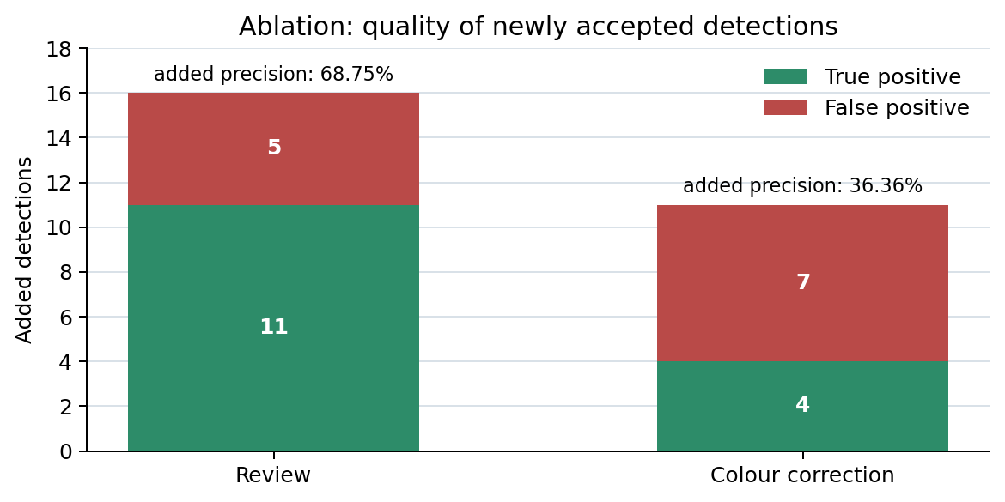
Figure 5.2 - Quality of the new detections added by Review and colour correction.
Component | TP | FP | Precision of additions | Overall F1
Review only | 11 | 5 | 68.75% | 89.97%
Colour correction only | 4 | 7 | 36.36% | 89.38%
P0 - baseline | - | - | - | 89.49%

Review was the more beneficial and stable component: it recovered 11 true objects at the cost of five false detections, and produced the highest overall F1 in the ablation. Colour correction slightly reduced F1. In six of its seven false corrections, the box was correctly placed on a tomato labeled unripe, but the colour rule changed its class to ripe.
This finding indicates a mismatch between the warm rule and the annotation policy: orange tones were sometimes labeled unripe in the Ground Truth. Colour correction should therefore not be considered beneficial merely because it raises Recall. It should be calibrated to the dataset's maturity definition, possibly using an intermediate category or a stricter red threshold.
Ablation conclusion
Review should remain in the policy. Colour correction requires recalibration before it can be presented as an improvement.

5.5 Temporal Consistency in Greenhouse Videos
Three clean greenhouse videos recorded on 5 July 2026, totalling approximately 90.1 seconds, were sampled at 3 FPS and yielded 271 frames. A detection was defined as temporally supported if it belonged to a track with at least five appearances over at least one second. This metric measures persistence, not correctness against Ground Truth.
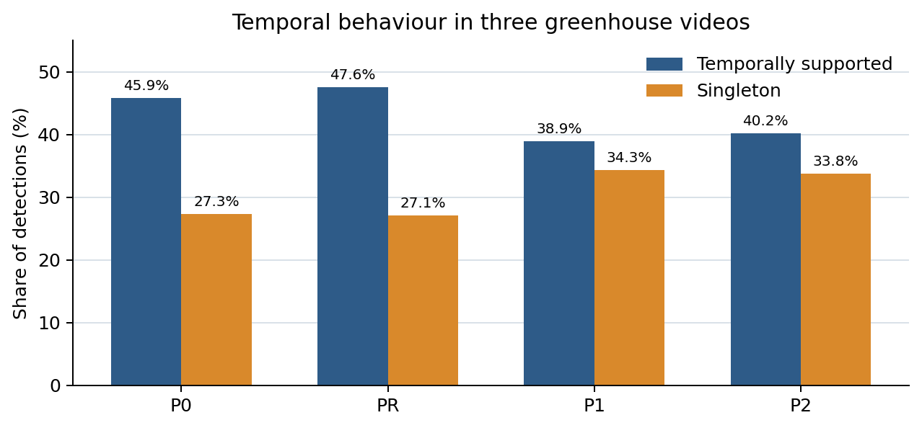
Figure 5.3 - Temporal-support and singleton rates for the four configurations.
Policy | Detections/frame | Stable tracks | Supported | Singleton
P0 | 0.756 | 12 | 45.85% | 27.32%
PR | 0.830 | 13 | 47.56% | 27.11%
P1 | 1.365 | 19 | 38.92% | 34.32%
P2 | 1.387 | 20 | 40.16% | 33.78%

Review added 20 detections, 13 of which 65% belonged to stable tracks; the singleton rate was almost unchanged. By contrast, colour correction accounted for 145 of the 165 detections added between P0 and P1, but only 25.5% belonged to stable tracks, and 66 appeared as singletons.
Interpretation
Review increased coverage without adding substantial transient noise. Colour correction increased coverage but also instability and class switching, consistent with the Precision decrease on the annotated set.

5.6 Cluster Heuristic and Session Results
The heuristic did not activate on the static test set: the ten weak cluster anchors did not jointly satisfy the confidence, area, and density conditions. In the videos, however, it activated six times - five in the second video and once in the third - and created four tracks. One track was stable for three seconds. All six predictions were classified as Unripe bunch.
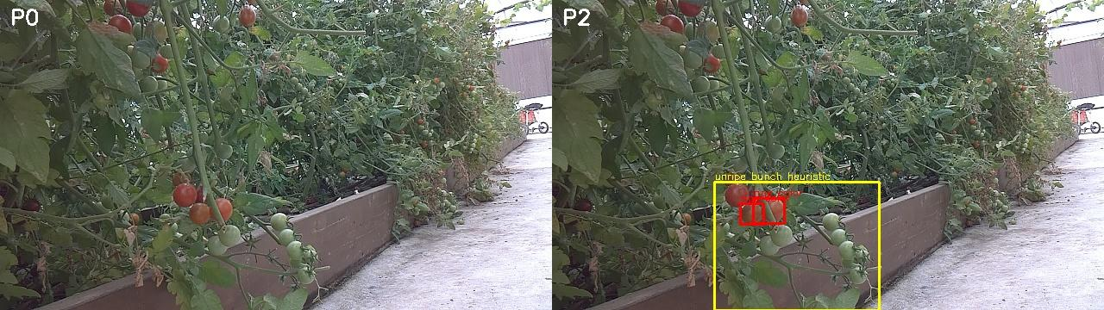
Figure 5.4 - Video example: P0 on the left and the heuristic cluster added by P2 on the right.
Sample | Events | Candidates | Heuristic predictions
8 Sessions - 30.6.2026 | 1,297 | 14,792 | Inactive
7 Sessions - 5.7.2026 | 1,146 | 13,785 | 177

Prediction type on 5 July | Count
Strong | 279
Review | 493
Color corrected | 616
Heuristic: unripe / ripe / Mixed | 147 / 23 / 7
Weak / Noise | 8,300 / 3,219

P2 added approximately 0.022 detections per frame relative to P1 in the videos-a significant change-but the increase in temporal support and reduction in singletons were not significant. The Sessions and videos lack Ground Truth; therefore, the 177 predictions demonstrate that the heuristic operated under greenhouse conditions and produced all three cluster classes, but they do not establish an accuracy improvement.

5.7 Discussion, Answer to the Research Question, and Conclusions
The hybrid combination measurably improved detection sensitivity: Recall increased significantly by 1.82 percentage points and missed detections decreased by 15. This gain came at a cost-Precision decreased significantly by 1.29 points, while changes in F1 and Object Accuracy were not significant. The policy therefore shifted the operating point toward greater coverage rather than producing an unequivocal overall performance improvement.
At the component level, Review provided the most convincing contribution. Colour correction increased coverage but requires recalibration. The heuristic exploited weak anchors and bridged frames in which direct cluster prediction disappeared, but the sample was small and lacked Ground Truth. Live deployment on the Jetson Orin Nano with TensorRT FP16 demonstrates operational feasibility; however, because end-to-end FPS was not measured on the robot, the real-time element of the research question is answered qualitatively rather than fully quantitatively.

Limitations and Future Work
The sample contains 66 images, few clusters, no Mixed class, and no negative test images. The three videos were recorded on one day, and the heuristic activated only six times. Future work should include video annotation, colour calibration by maturity stage, direct tracking of heuristic clusters, evaluation in additional greenhouses, and measurement of FPS, processing time, and resource use directly on the robot.

Key Conclusions
1 - Explainable rules can recover genuine detections rejected by a conservative threshold.
2 - Each rule must be evaluated independently; more detections do not necessarily mean greater accuracy.
3 - Consistent noise is a useful information source for clusters, but Ground Truth is required to quantify its accuracy.

References
Moreira, G., Magalhães, S. A., Pinho, T., dos Santos, F. N., & Cunha, M. (2022). Benchmark of deep learning and a proposed HSV colour space models for the detection and classification of greenhouse tomato. Agronomy, 12(2), 356. https://doi.org/10.3390/agronomy12020356
Wei, J., Sun, Y., Luo, L., Ni, L., Chen, M., You, M., Mu, Y., & Gong, H. (2025). Tomato ripeness detection and fruit segmentation based on instance segmentation. Frontiers in Plant Science, 16, 1503256. https://doi.org/10.3389/fpls.2025.1503256
Weng, W., Lai, Z., Cui, Z., Chen, Z., Chen, H., Lin, T., Wang, J., Zheng, S., & Chen, G. (2025). GCD-YOLO: A deep learning network for accurate tomato fruit stalks identification in unstructured environments. Smart Agricultural Technology, 12, 101465. https://doi.org/10.1016/j.atech.2025.101465
Buzhidao. (n.d.). TOMATO [Data set]. Roboflow Universe. Retrieved July 11, 2026, from https://universe.roboflow.com/buzhidao-mkdfs/tomato-h72eq

Appendices

Appendix A - Hardware Architecture
The figure presents all robot components, including processing and power units, environmental sensors, camera mechanism, mobile base, and control devices.

Figure A.1 - Complete hardware architecture.
Split | Main components
Processing | Jetson Orin Nano 8 GB, UPS, 8-inch display
Sensing | IMX219, LiDAR, IMU, temperature sensor, two ultrasonic sensors
Control and motion | RaspbotV2/STC8, Machina Climbing Car Pro, PS4 controller
Communication | TP-Link M7200, Wi-Fi, and 4G LTE

Appendix B - Software Architecture
The complete diagram illustrates the separation among the computer-vision, mapping, and control paths and their convergence in the Session record and client application.

Figure B.1 - Complete software architecture.

Appendix C - Full Processing Flowchart
This diagram includes the second ROI pass, colour correction, Review, the heuristic, tracking, and recording. It was moved to the appendices to keep the main report focused.
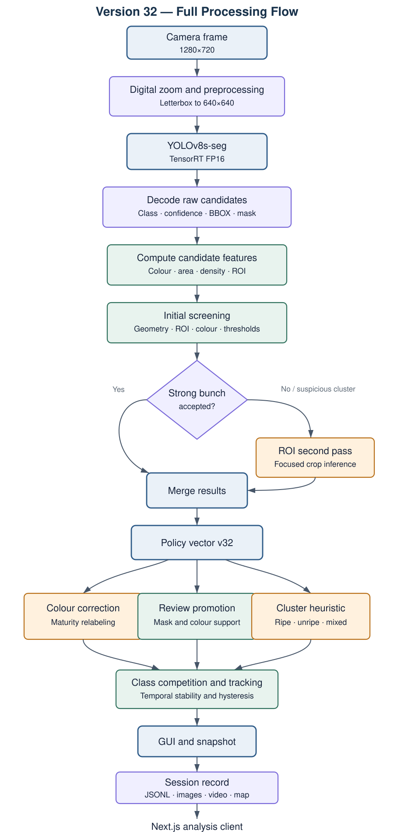
Figure C.1 - Complete processing flow in version 32.

Appendix D - Dataset and Training Details
Training parameter | Value
Initial model | YOLOv8s-seg pretrained
Input size / batch | 640×640 / 8
Epochs | 30 planned; stopped at epoch 14
Early Stopping | 10
GPU | NVIDIA RTX 4060 Ti
Number of parameters | 11,781,148
Complexity | 39.9 GFLOPs
best.pt | Epoch 4
Training time | Approximately 2.27 hours

Complete Validation Metrics
Class | Box P | Box R | Box mAP50 | Mask P | Mask R | Mask mAP50 | Mask mAP50–95
All | 0.868 | 0.889 | 0.914 | 0.673 | 0.674 | 0.641 | 0.451
Ripe bunch | 0.876 | 0.886 | 0.905 | 0.490 | 0.474 | 0.366 | 0.097
Ripe | 0.923 | 0.943 | 0.954 | 0.928 | 0.935 | 0.946 | 0.835
Unripe | 0.821 | 0.863 | 0.879 | 0.832 | 0.853 | 0.879 | 0.780
Unripe bunch | 0.850 | 0.864 | 0.918 | 0.442 | 0.435 | 0.374 | 0.092

Note: these metrics were calculated on 133 validation images. The original training notebook did not include a separate test-set evaluation; the evaluation on the 66 test images was performed in the later comparison notebook and is described in Chapter 5.

Appendix E - Policy Thresholds and Pseudocode
Parameter | Value
Raw candidate threshold | 0.15
NMS IoU | 0.45
Ripe tomato | 0.80
Unripe tomato | 0.85
Ripe bunch | 0.65
Unripe bunch | 0.70
Overlap threshold for heuristic-cluster filtering | 0.30
Minimum margin for cluster-maturity decision | 0.60

candidates = decode_yolo(frame, raw_threshold=0.15)
candidates = nms(candidates, iou=0.45)
for c in candidates:
c.features = mask_colour_density_roi(c)
c.status = strict_policy(c)
c = maybe_review_or_colour_correct(c)
heuristic_bunches = infer_bunches(weak_anchors, tomatoes)
accepted = maturity_competition(accepted + heuristic_bunches)
stable = temporal_tracking(accepted)
save(raw=candidates, final=stable)

Additional area, density, and colour thresholds are retained in the version 32 code and Policy Replay reports. They should be managed in an external configuration file, with a version and hash reported for each experiment to ensure reproducibility.

Appendix F - Detailed Results

Paired-Bootstrap Confidence Intervals
P1−P0 comparison | Change | 95% CI | Significant
Precision | −1.27 pp | −2.13 to −0.58 | Yes
Recall | +1.82 pp | +0.99 to +2.76 | Yes
F1 | +0.36 pp | −0.21 to +0.95 | No
Object Accuracy | +0.59 pp | −0.34 to +1.56 | No

Per-Class Results
Class | Policy | Precision | Recall | F1
Ripe tomato | P0 | 92.78% | 89.29% | 91.00%
Ripe tomato | P1 | 90.93% | 91.47% | 91.20%
Unripe tomato | P0 | 93.75% | 80.58% | 86.67%
Unripe tomato | P1 | 93.43% | 82.23% | 87.47%
Ripe bunch | P0/P1/P2 | 88.37% | 82.61% | 85.39%
Unripe bunch | P0/P1/P2 | 100% | 85.71% | 92.31%

Summary of the Seven Post-Update Sessions
Strong | Review | Color | Heuristic | Weak | Noise
279 | 493 | 616 | 177 | 8,300 | 3,219

These counts are not Accuracy measures because the dates represent different routes and conditions without shared Ground Truth. They verify that the new code ran, recorded statuses, and generated clusters on the robot hardware.

Appendix G - Examples from the Annotated Test Set
Each image shows P0 on the left and P2 on the right. The examples illustrate that most detections remained unchanged, while some cases gained Review detections or colour corrections.
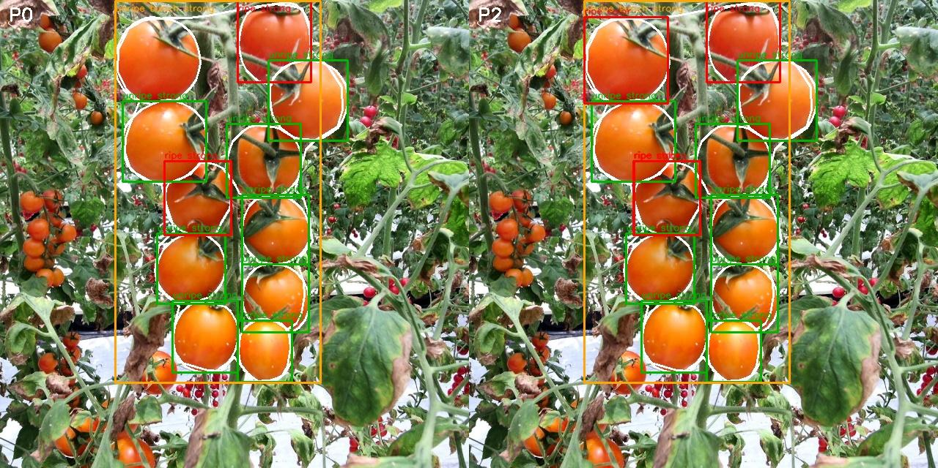  G.1 - Dense cluster | 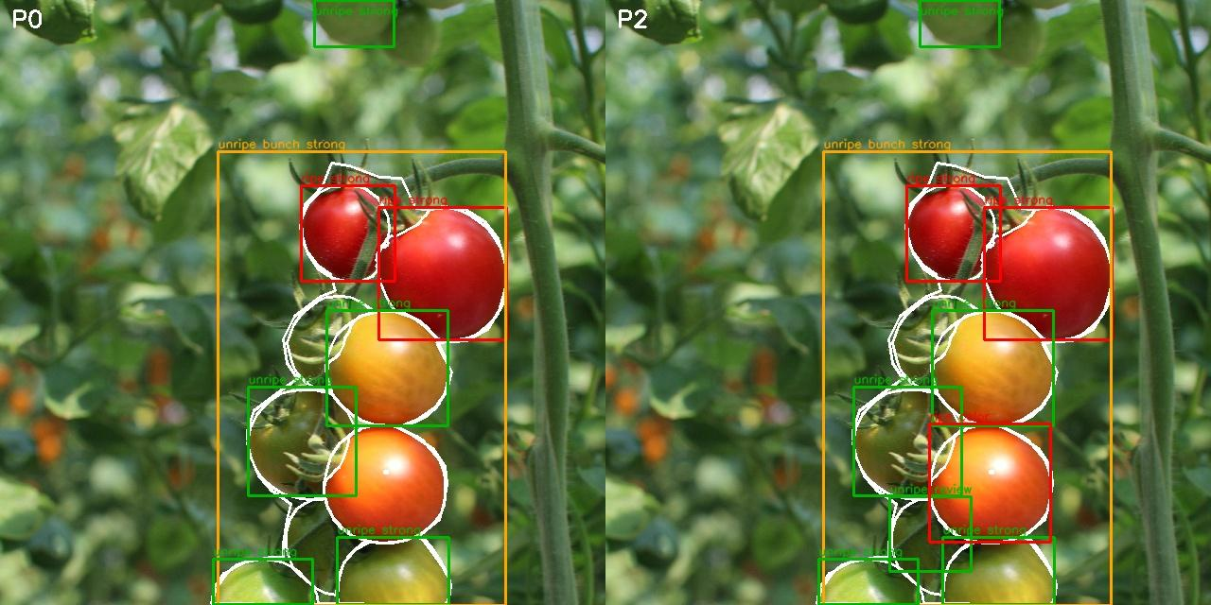  G.2 - Different maturity stages
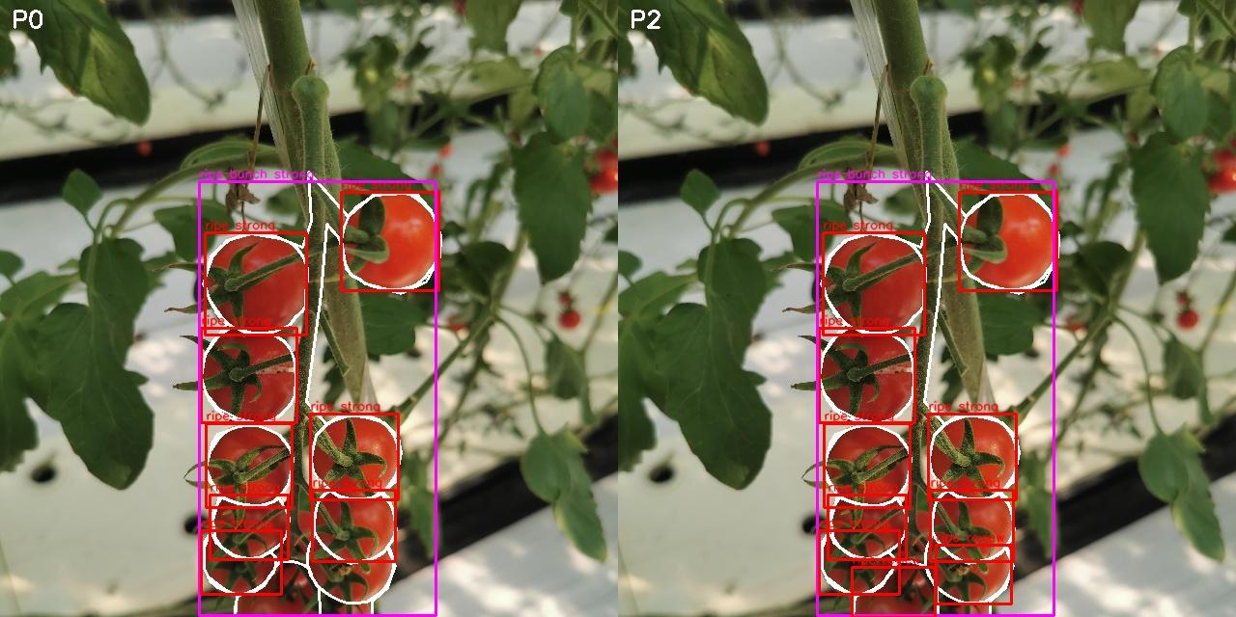  G.3 - Ripe cluster | 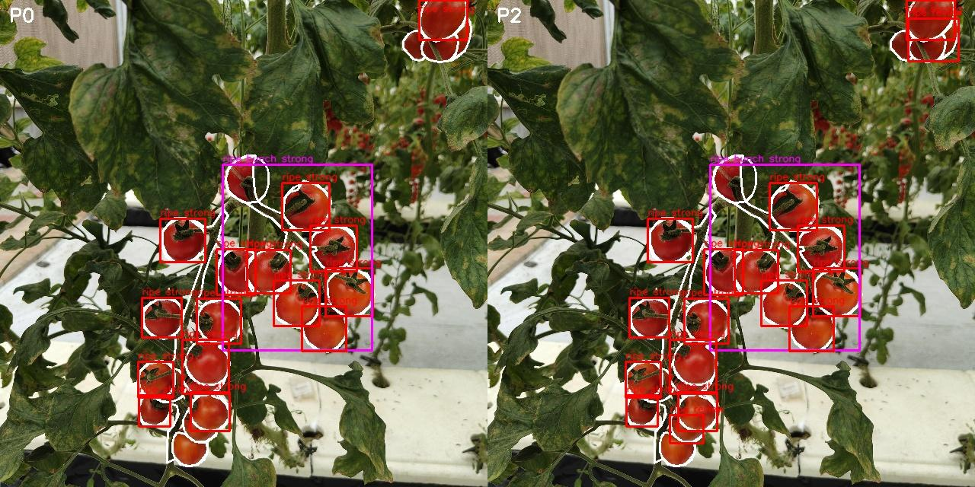  G.4 - Occlusion by leaves

The boxes should be interpreted together with the metric tables: a single visual example does not prove improvement, but it helps explain how policy additions appear in a scene.

Appendix H - Heuristic Examples from Greenhouse Videos
In each pair, the left frame is P0 and the right frame is P2. The yellow box represents a cluster generated by the heuristic.

Figure H.1 - Heuristic cluster in a greenhouse video.
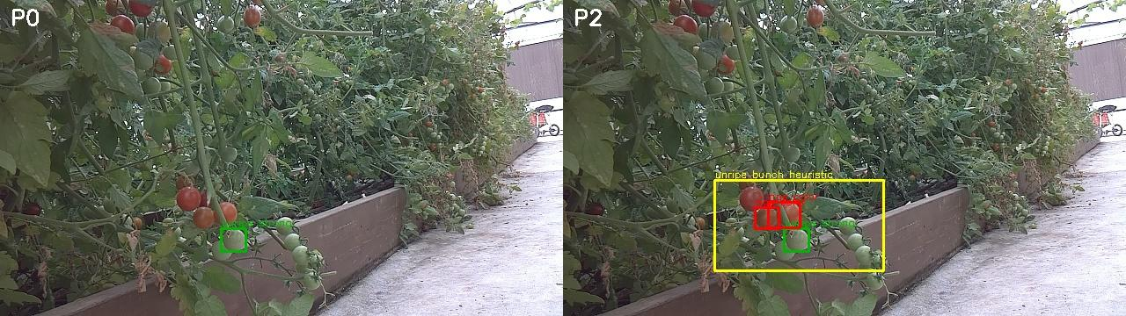
Figure H.2 - Heuristic cluster in a greenhouse video.
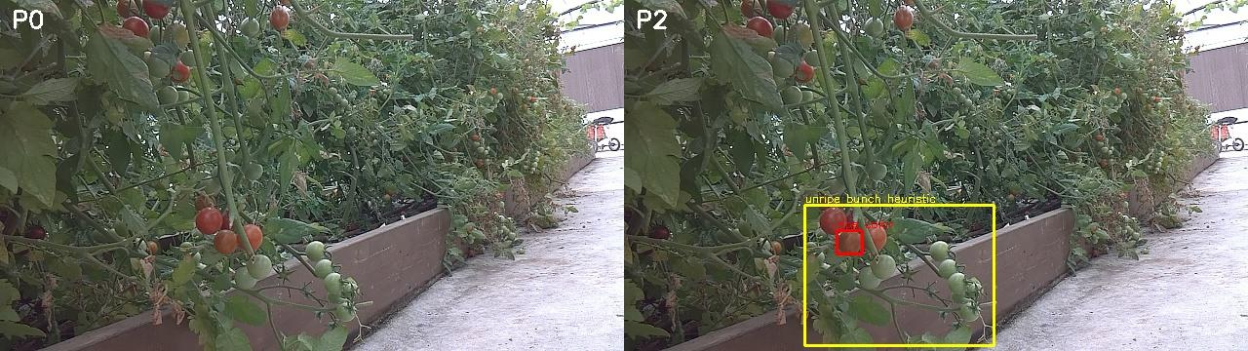
Figure H.3 - Heuristic cluster in a greenhouse video.

Appendix I - Additional Video Examples
The examples show different illumination, viewing-angle, and occlusion conditions. Some also include direct model cluster predictions alongside the heuristic result.
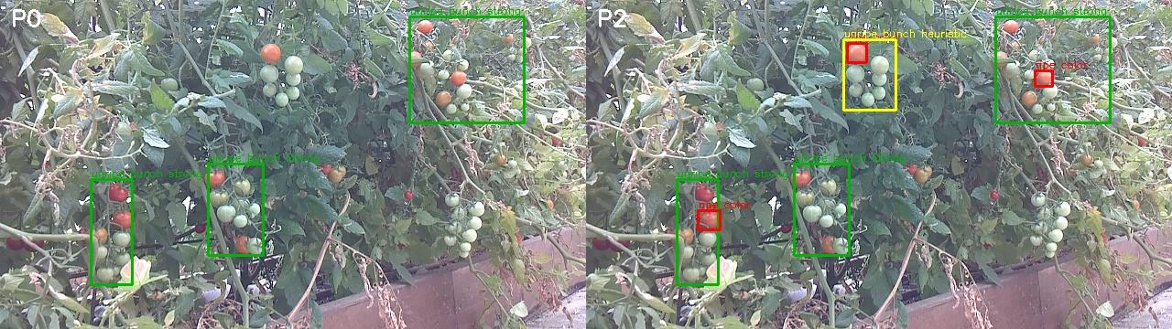
Figure I.1 - P2 operating in a dense greenhouse scene.
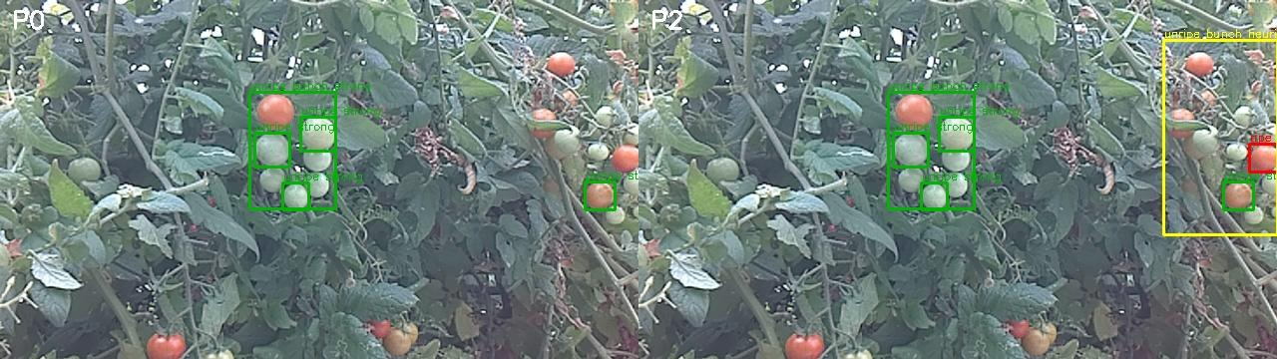
Figure I.2 - P2 operating in a dense greenhouse scene.
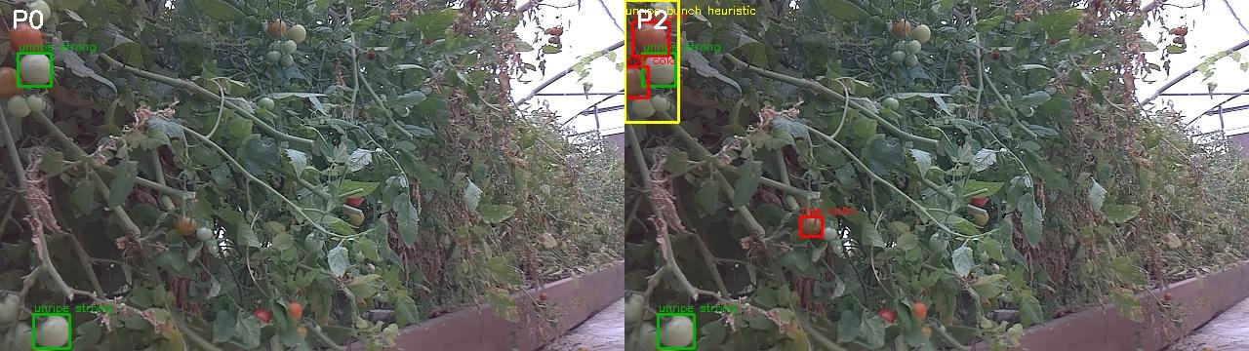
Figure I.3 - P2 operating in a dense greenhouse scene.
Without Ground Truth for the videos, these figures demonstrate feasibility only. A future publication should annotate video segments at track level and compare clusters against a manual reference.

J.1 Purpose and Session-Level View
The Next.js client provides a dedicated Dashboard for replaying and analysing recorded robot Sessions. It consolidates the scan timeline, robot video, environmental measurements, mapped detections, policy filters, and aggregate statistics in a single interface. The Dashboard does not rerun YOLO; it visualizes the recorded raw candidates and post-policy results so that the experiment can be inspected without operating the robot again.
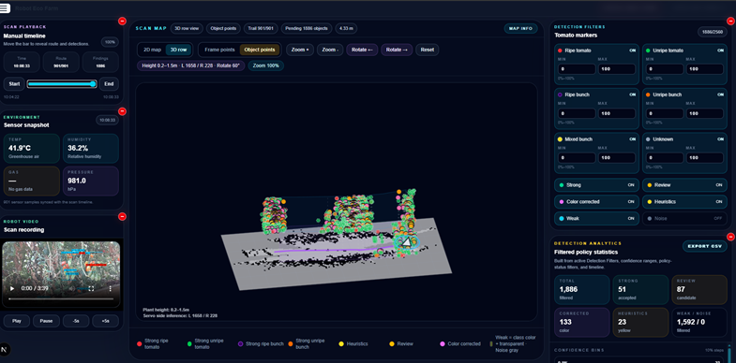
Figure J.1 - Dashboard for synchronized Session playback, spatial mapping, policy filtering, and aggregate detection analysis.
Dashboard area | Research function
Scan playback | Synchronizes time, route position, findings, video, and sensor samples.
2D/3D scan map | Displays the robot trail and prediction locations as spatial object points.
Detection filters | Filters by class, confidence range, and policy status: Strong, Review, Color corrected, Heuristic, Weak, or Noise.
Detection analytics | Summarizes the filtered population and supports CSV export for external analysis.

J.2 Detection Evidence Review
Selecting a finding opens the Detection Evidence Review workspace. The user can navigate between frames and objects, switch between the clean image and the complete overlay, and inspect every candidate that contributed to the frame. Frame-level indicators report the number of displayed objects, raw candidates, heuristic results, policy categories, and estimated map coordinates.
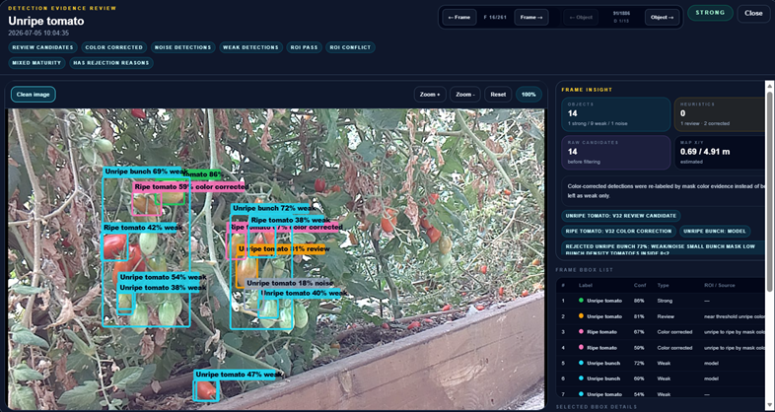
Figure J.2 - Frame-level evidence review with candidate overlays, policy explanations, raw-candidate counts, and the complete BBOX list.
Evidence element | Interpretation
Reason badges | Identify Review, Color corrected, Weak, Noise, ROI-pass, ROI-conflict, Mixed-maturity, and rejection-reason cases.
Frame BBOX list | Lists class, confidence, policy type, source, and the reason associated with each candidate.
Frame insight | Compares visible objects with raw candidates and reports heuristic activity and map position.
Frame/object navigation | Supports systematic error review without manually searching the Session folders.

Traceability contribution
The interface preserves the distinction between model output and policy decisions. A detection can therefore be traced from its raw candidate to its displayed status and rejection or promotion reason.

J.3 Selected-Object Diagnostics and Research Use
The selected-object view isolates one candidate while retaining its frame context. It exposes the predicted label, original confidence, policy type, colour rule, bounding box, track identifier, source, mask density, warm-colour ratio, red ratio, and green/yellow ratio. This information is particularly useful for examining near-threshold Review candidates and incorrect colour corrections.
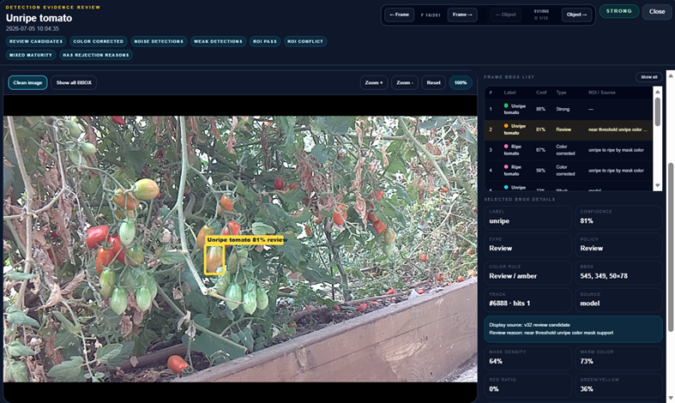
Figure J.3 - Selected Review candidate with policy source, confidence, tracking data, mask density, and colour evidence.

J.4 Contribution to the Evaluation Workflow
The Dashboard supports the research workflow in four ways: it links detections to time and location; enables rapid qualitative inspection of false positives and missed candidates; exposes the evidence used by the policy vector; and exports filtered results for quantitative processing. It also makes the Session archive understandable to a reviewer who did not participate in the greenhouse run.
Use | Outcome
Policy debugging | Locate recurring Review, Color corrected, Weak, and Noise patterns.
Temporal analysis | Compare detections across frames, tracks, and route positions.
Reproducibility | Retain the image, candidate attributes, policy source, and map context for each finding.
Reporting | Generate screenshots and CSV summaries for the report and later publication.

Interpretation limitation
The Dashboard is an analysis and traceability tool, not a Ground Truth annotation system. Its counts describe recorded model and policy outputs; Precision, Recall, F1, and Accuracy still require independently annotated reference data.

